Transformo Docs Application: Empowering Machine Readable Document Management System

K.Vasuki1, a

M. Jayanth Kumar, b

K. Jashuva,c

Madhavi Durga Dasari4,c

Author Affiliations

1,2,3,4JNTU-GV COLLEGE OF ENGINEERING, VIZIANAGARAM

JAWAHARLAL NEHRU TECHNOLOGICAL UNIVERSITY- GURAJADA VIZIANAGARAM

DWARAPUDI, VIZIANAGARAM, ANDHRA PRADESH – 535003.

(A constituent college of JNTU-GV & Approved by AICTE ,New Delhi)(Recognised by UGC under section 2(f)&12(B) of UGC Act 1956)

Author Emails

[Jayanthjay9922@gmail.com](mailto:Jayanthjay9922@gmail.com)a

[Jashuakumba209@gmail.com](mailto:Jashuakumba209@gmail.com)b

Vasukikudali@gmail.comc

[madhavidurga2204@gmail.com](mailto:madhavidurga2204@gmail.com) d

**Abstract:**

The Document Processing and OCR Automation project provides an efficient solution for extracting and converting text from PDF and DOCX files into a machine-readable JSON format. This Python-based system automates the process of handling both digital and scanned documents, ensuring accurate text extraction through the integration of libraries like pdfplumber , docx2txt , and easyocr for Optical Character Recognition (OCR).

The project addresses the challenge of converting unstructured or image-based content into structured data, making it suitable for a wide range of applications, including data analysis, digital archiving, and content management systems. By automating the text extraction and conversion process, the system enhances productivity and reduces manual effort, offering a scalable and reliable solution for managing diverse document types.

1.**Introduction**:

The Document Processing and OCR Automation project is a Python-based solution designed to simplify the process of extracting and converting text from various document formats, such as PDF and DOCX, into a machine-readable JSON format. The project addresses a common challenge in data handling: converting both digital and scanned documents into an editable, structured format for further processing or analysis.

The script leverages advanced libraries like easyocr , pdfplumber , and docx2txt to extract text efficiently. For scanned documents or image-based PDFs, it uses Optical Character Recognition (OCR) to ensure no information is lost. This automation is valuable for organizations and individuals dealing with large volumes of documents, as it transforms unstructured data into accessible, organized, and searchable formats.

With its user-friendly workflow and robust functionality, this project serves as a powerful tool for digital transformation, enabling seamless integration of document processing into various applications such as data analysis, machine learning, and archival systems.

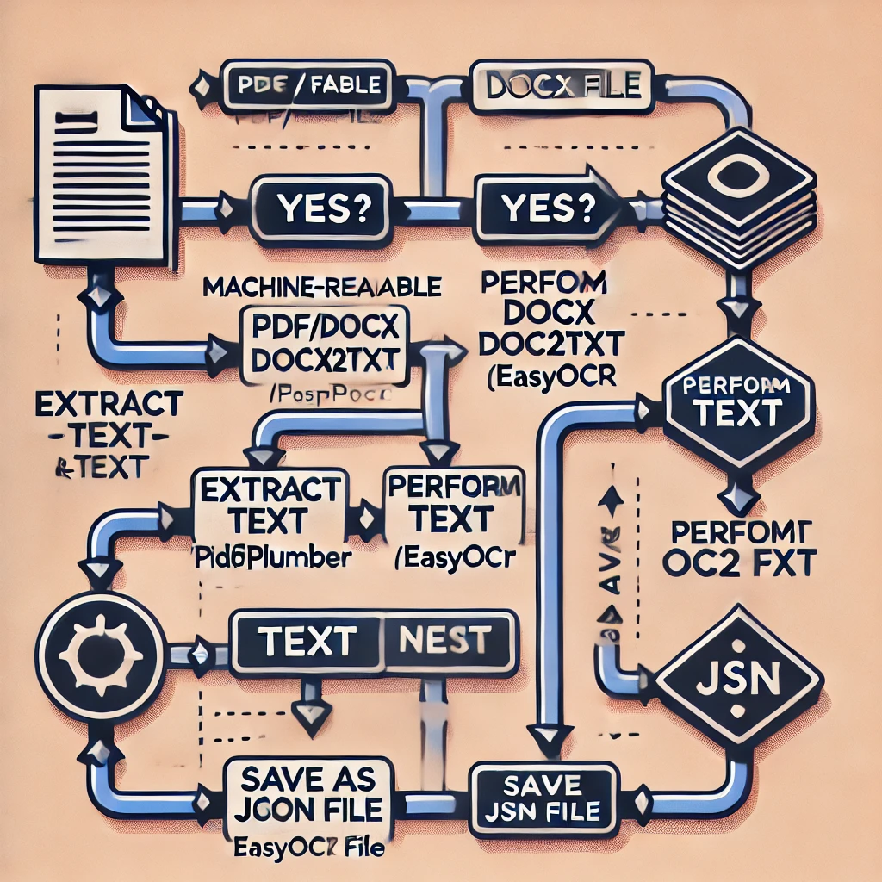

Workflow:

Identify File Type: This step determines whether a document is already in a machine-readable format. The script checks the file extension—if it’s `.txt` or `.json`, the document is considered machine-readable, meaning the text content can be directly accessed without further processing. For other formats like `.pdf` or `.docx`, additional steps such as text extraction or OCR are required to make the content machine-readable.

**Text Extraction Process:**

Text extraction is a crucial step in the document processing workflow, enabling the conversion of unstructured document content into machine-readable formats. This process varies depending on the type of document being processed, such as PDFs or DOCX files. Below is a brief explanation of how text extraction is handled for each file type:

**1. PDF Files:**

PDFs come in two primary forms: digitally created (machine-readable) and scanned (image-based). The extraction process differs based on the content type:

1. **Machine-readable PDFs:**

* For PDFs containing selectable text, the script uses the **pdfplumber** library.
* **pdfplumber** efficiently extracts text from each page by reading the document's underlying structure.
* It processes tables, text layouts, and complex formatting while preserving the content structure, making it ideal for digitally created PDFs.

**b. Scanned PDFs:**

* **Scanned PDFs contain images of text rather than digital text. In such cases, pdfplumber cannot directly extract text.**
* **The script applies Optical Character Recognition (OCR) using easyocr.**

**2. DOCX Files:**

DOCX files are inherently machine-readable and typically contain digital text, making extraction more straightforward:

* The script uses the **docx2txt** library, which efficiently reads and extracts text content from DOCX documents.
* **docx2txt**:
  + Preserves the document's formatting.
  + Extracts all the text, including headings, paragraphs, and bullet points.
  + Ensures no text content is missed, even from complex layouts.

Unlike PDFs, DOCX files rarely require OCR since they are already in a digital format.

OCR Processing:

OCR (Optical Character Recognition) processing is a technology that converts images containing text—such as scanned documents or photos of signs—into machine-readable text. When OCR is applied, the system first identifies text regions within the image, then processes those regions to recognize individual characters or words.

In the context of EasyOCR , a popular OCR library, this process is simplified using deep learning models trained to recognize text in multiple languages. EasyOCR detects the location of text in an image, then interprets the detected areas into digital text. This output can be used for various purposes, like data extraction, indexing, or translation.

EasyOCR specifically stands out for its ability to handle complex scripts and its support for multiple languages, making it a robust choice for applications requiring accurate and versatile text recognition

* Optical Character Recognition (OCR) is a technology designed to extract text from images, making it editable and searchable. It plays a vital role in converting unstructured image data—such as scanned documents, photographs of text, or image-based PDFs—into structured, machine-readable formats. This process involves analyzing the visual structure of an image, recognizing characters, and converting them into digital text.

Key Steps in OCR for Images:

1. Image Preprocessing:

* Before extracting text, the image is often preprocessed to enhance its quality.
* Techniques such as resizing, binarization (converting the image to black and white), and noise reduction help improve OCR accuracy.

2. Text Detection:

* OCR systems first identify regions within the image that likely contain text.
* This step isolates text from non-text elements like images, lines, or other graphical content.

3. Character Recognition:

* The identified text regions are analyzed character by character.
* Advanced OCR tools use machine learning models, often based on neural networks, to improve accuracy in recognizing various fonts, sizes, and styles.

4. Post-Processing:

* Extracted text is cleaned and formatted, correcting any errors in recognition.
* Common techniques include spell-checking and context-based error correction to ensure the text matches the intended content.

Benefits of OCR:

* Accessibility: Converts printed or handwritten text into digital formats, making it accessible to assistive technologies.
* Searchability: Enables keyword searching within documents.
* Data Analysis: Allows text data from images to be processed and analyzed in applications like machine learning

.

Applications of OCR:

* Digitizing Documents: Libraries, archives, and offices use OCR to digitize books, forms, and records.
* Automating Data Entry: OCR simplifies extracting data from receipts, invoices, and business cards.
* Text Extraction from Media: Extracts subtitles from images or video screenshots for editing or translation.

Example in Action:

* In this project, EasyOCR is employed to process image-based PDFs or scanned documents. The tool scans the image, identifies textual components, and converts them into editable text. This ensures that even non-machine-readable files can be processed and converted into structured formats like JSON.
* By transforming images into editable and searchable text, OCR technology bridges the gap between physical and digital information, making it a cornerstone of modern data processing systems.

**JSON Conversion**:

After extracting text from an image or document, the OCR script saves this information in a JSON (JavaScript Object Notation) file . JSON is a structured, human-readable format that organizes data as key-value pairs, making it easy to store and access specific pieces of information.

Key Points:

1. Structured Format: JSON organizes extracted text in a structured way, which can include additional details like page numbers, sections, or timestamps, allowing for easy navigation and use.

2.Compatibility: JSON is widely compatible with many programming languages and tools, which means the extracted data can be readily imported, analyzed, or modified in various applications.

3. Data Flexibility: By saving text in JSON, the data can be programmatically filtered, searched, and updated, facilitating tasks such as data analysis, indexing, and integration with databases.

4. Automation Ready: JSON files are ideal for feeding data into automated workflows or APIs, supporting seamless data transfer between systems.

5. Reusable and Archivable: JSON files can be stored as long-term records of the extracted content, making them useful for future reference or batch processing.

Saving extracted text as JSON makes the data manipulation process easier, especially for applications that require organized, reusable, and flexible data formats.

**User-Friendly Output:**

In this script, Colorama is used to add colored text to the terminal output, making it easier to distinguish different types of messages (like errors, warnings, and confirmations). This improves user experience by enhancing the readability of log messages.

Key Points:

1. Enhanced Readability: By using colors, critical information such as errors or successful completions can stand out, allowing users to quickly scan for important details.

2. Visual Feedback: Color-coded messages provide immediate visual feedback, helping users understand the script's status or any issues at a glance.

3. Customizable Output: Colorama allows customization of colors, making it possible to adapt the script's output to the user’s preferences or the script's specific needs.

4. Cross-Platform Compatibility: Colorama works on Windows, macOS, and Linux, ensuring that colored output appears consistently across different operating systems.

Using Colorama in terminal output makes the script more user-friendly, especially when dealing with complex processes or large amounts of information.

**9. Conclusion**

his OCR-based document processing project successfully automates the extraction and conversion of text from PDF and DOCX files into a machine-readable JSON format. By leveraging **EasyOCR** for text recognition and **Colorama** for user-friendly, color-coded terminal output, the script provides a seamless and efficient way to handle both text-based and image-based documents.